Apache Sling Request Processing Analyzer - Adobe Experience Manager (AEM

Sling Request Processing Analyzer helps to analyze huge requests during load testing or other cases to identify the time taken by individual request and identify the requests that taking more time to process.

Sling Request Processing Analyzer logs each request in a special file – ${sling.home}/logs/requesttracker.txt.

Ex: C:\Vinay\**********\AEM Server\author\crx-quickstart\logs\requesttracker.txt.

By default 20 recent requests would be capture in the console. Can be changed from config manager.

Recent request console can be access from the below mentioned URL:

<http://localhost:4502/system/console/requests>

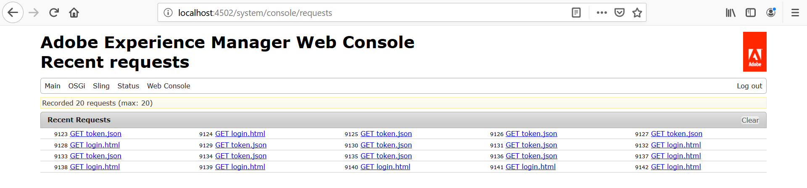

The no.of recent request records to be captured can be changed as mentioned below.

1. Go to config manager console.

<http://localhost:4502/system/console/configMgr>

1. Search for “Apache Sling Main Servlet”.
2. Open the configuration and update the “Number of Requests to Record” value to the desired value.

Ex: 30 (so that in requests console, we would be able to see recent 30 request details)

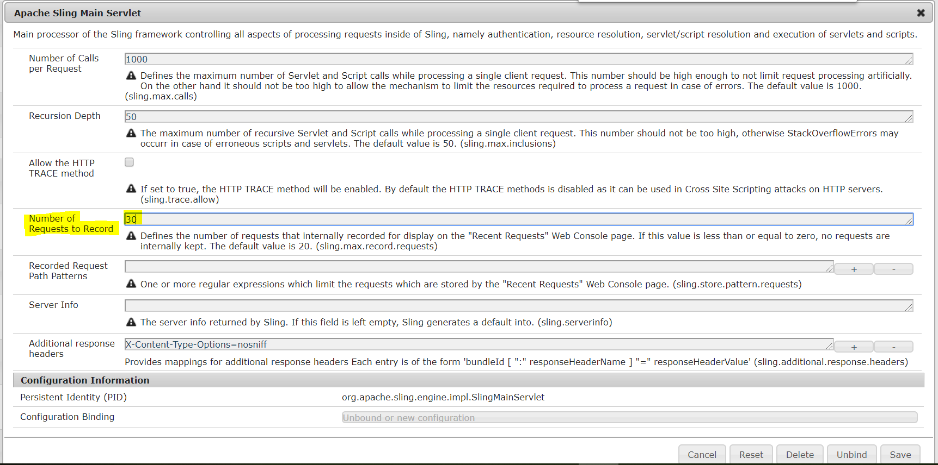

**Configuring request processing analyzer:**

Request processing analyzer can be downloaded from the blow GitHub location.

[**https://github.com/apache/sling-org-apache-sling-reqanalyzer**](https://github.com/apache/sling-org-apache-sling-reqanalyzer)

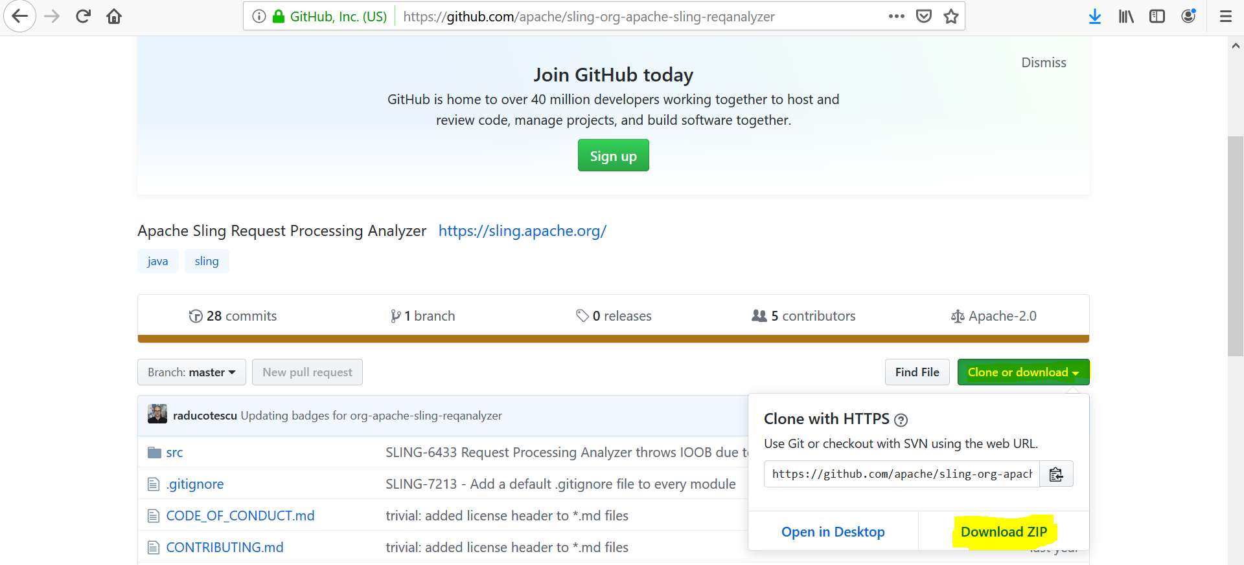

After downloading the zip file, extract it and a code build is required to upload the bundle into OSGI console to make use of this utility.

C:\Vinay\AEM Training\Concepts List\Bundles or packages\sling-org-apache-sling-reqanalyzer-master\sling-org-apache-sling-reqanalyzer-master

Go to the above mentioned location (this is location after extracting) and execute the build command.

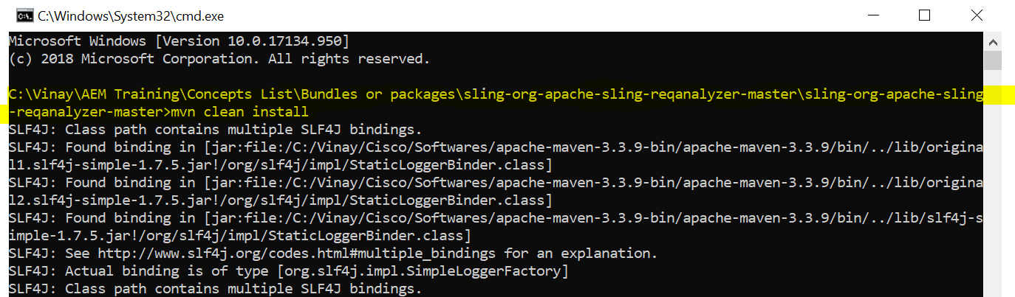

After successful build, we would see the success message in the console.

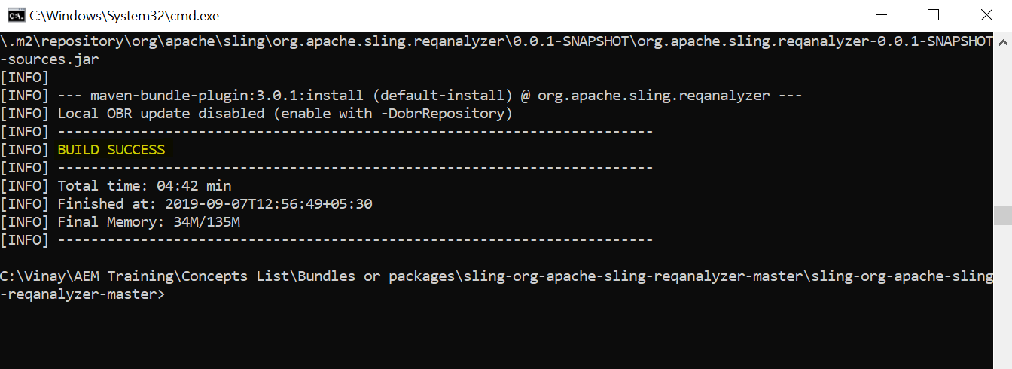

Once the bundle is successfully built, open the OSGI felix console and upload this bundle and make sure the bundle is in active state.

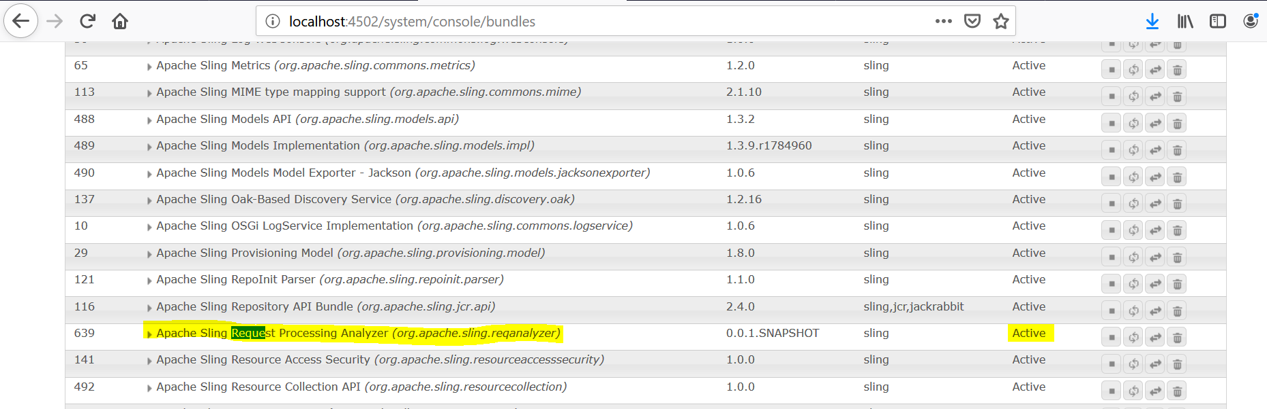

To make sure the setup is successful, go to logs folder and see if the “requesttracker.txt” file is created.

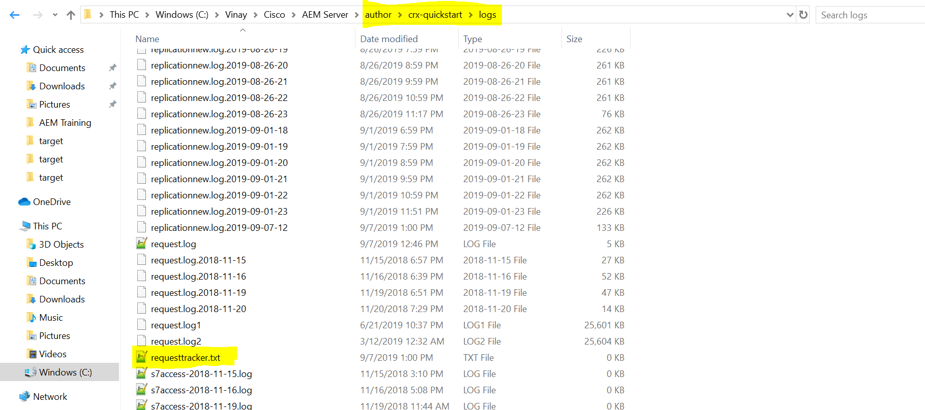

Initially when the file is created, the file size would be 0KB as no requests are captured so far. Once we access any resource, the file size would be changes and those tracked logs can be seen.

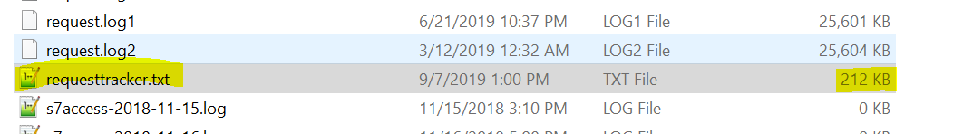

Here we can see the size of the file is increased.

To analyze this request analyzer track file, execute the below command after navigating to the file location.

**File location:** C:\Vinay\Cisco\AEM Server\author\crx-quickstart\logs

**Command -** java -jar C:\Users\vthalla\Desktop\org.apache.sling.reqanalyzer-0.0.1-SNAPSHOT.jar requesttracker.txt

After executing the above command, we would see a screen like captured below.

A window would be opened and after clicking on it, it would display the tracked request logs in details.

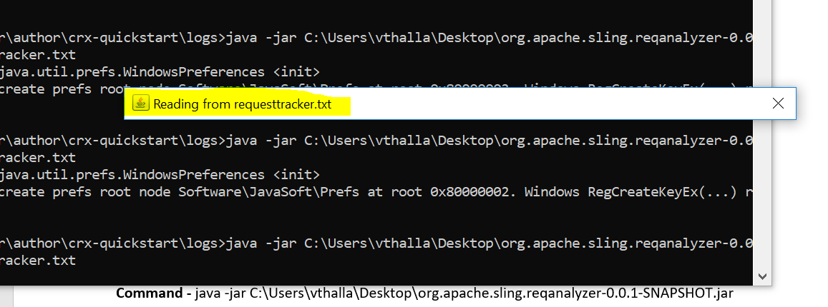

Click on it to see the full details.

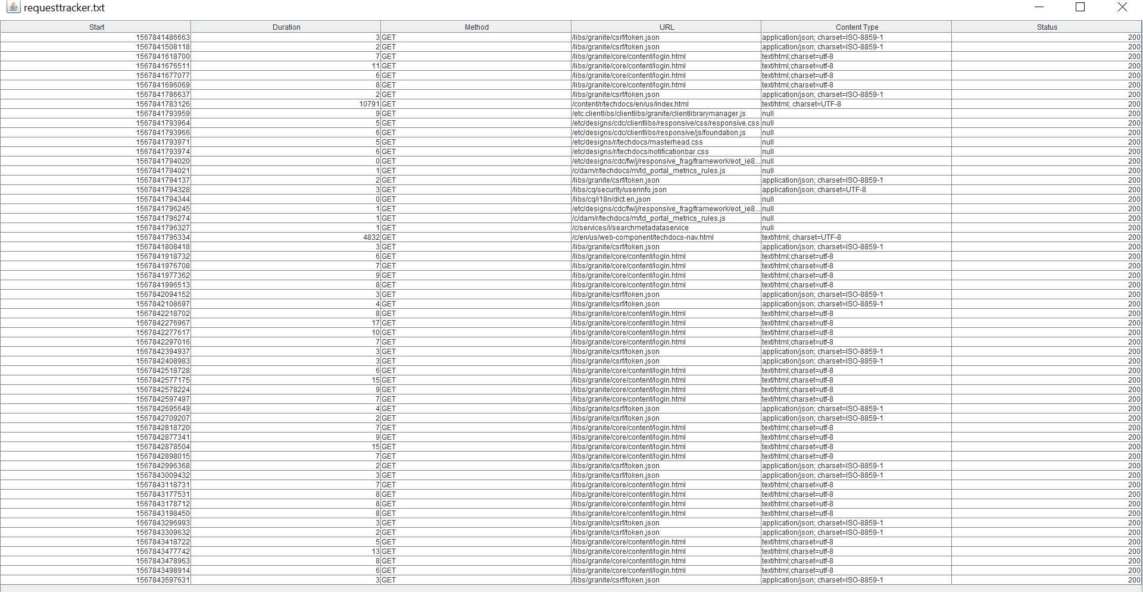

Method 2:

Go to OSGI request analyzer console and click on the action button to see the same behavior.

<http://localhost:4502/system/console/requestanalyzer>

After window opens, click on it or else it will automatically open the detailed information window in a while.

